ITVC Tutorial-5

**Name: Rohit Deshpande**

**Roll No.: 16010122041**

**Batch: A2**

Q1 Draw graph of the following function and its fourier series (with n=50 and n=100)

Function: x+x^2

clc

L=%pi

x=0:0.01:2*L;

f=x+x^2;

a0=(1/(2*L)*inttrap(x,f));

for n=1:100

f1=f.*cos(%pi*n*x*(1/L));

a(n)=(1/L)* inttrap(x,f1);

end;

for n=1:100

f2=f.*sin(%pi*n*x*(1/L));

b(n)=(1/L)* inttrap(x,f2);

end;

subplot(2,1,1), plot(x,f);

u=0; y=0;

for n=1:100

u= a(n)*cos(%pi*n*x*(1/L))+ b(n)* sin(%pi*n*x*(1/L));

y=y+u;

end;

fs=y+ a0;

subplot(2,1,2), plot(x,fs);

title('Rohit 16010122041 x+x^2 if n=100','fontsize',5)

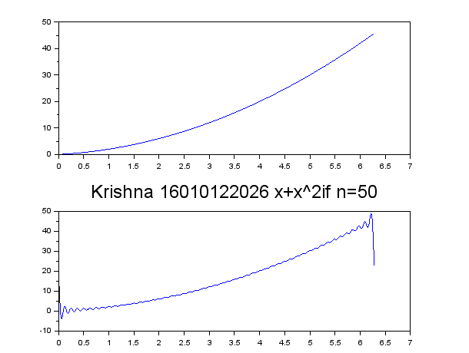

Q1 Draw graph of the following function and its fourier series (with n=5and n=20)

Function: sin(x)

clc

L=%pi

x=-L:0.01:L;

f=sin(x);

a0=(1/(2*L)*inttrap(x,f));

for n=1:5

f1=f.*cos(%pi*n*x*(1/L));

a(n)=(1/L)* inttrap(x,f1);

end;

for n=1:5

f2=f.*sin(%pi*n*x*(1/L));

b(n)=(1/L)* inttrap(x,f2);

end;

subplot(2,1,1), plot(x,f);

u=0; y=0;

for n=1:5

u= a(n)*cos(%pi*n*x*(1/L))+ b(n)* sin(%pi*n*x*(1/L));

y=y+u;

end;

fs=y+ a0;

subplot(2,1,2), plot(x,fs);

title('Rohit 16010122041 sin(x) if n=5','fontsize',5)

